PRINCIPLES OF BIG DATA MANAGEMENT

PHASE-2

BY

NAGA SRIVIDYA VARANASI-16269844

RISHITHA BOBBA-16274445

NAGA BINDU MADAMANCHI-16273070



1**.Objective**

The main goal of the project is to collect the real time twitter data in Json format and to analyze this data using apache spark. The tweets are stored using Spark SQL. Then, we wrote different analytical queries to understand the data and developed different visualizations on the data( using bar graph, pie chart, table chart etc.)

**2.System Requirements**

we need few languages and software that has to be installed in the system before collecting the data.

Languages: Python, Scala

Software requirements: Apache spark(version 2.3.1)

JDK 8

Scala (version 2.12.6)

**3. Architecture Diagram**

First, we collected the tweets about cryptocurrencies using twitter API.



**4. Implementation**

a) First we have started the spark shell.

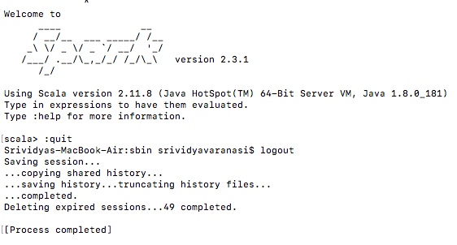

b) We loaded the json file into hdfs directory using the path:

val df = *spark.read.json("hdfs://localhost:9000/PB_Phase2/twitter_data_phase_2.txt")*

c) Converted the json data in the form of a table using:

*df.createOrReplaceTempView("twitter")*

d)Analytical queries to explore and to understand the data

Query1: This query tells about the top 20 verified users using the name and verified column from the data.

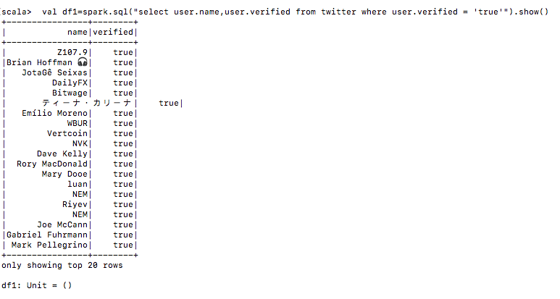

Visualization: We performed the visualization using table chart where the output is shown in tabular form.

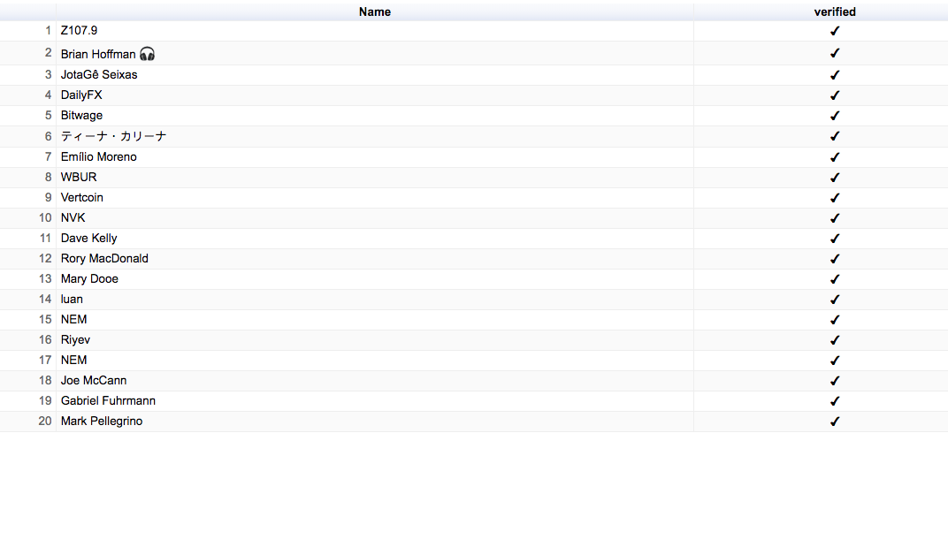

Query2: This query tells about which tweet is re-tweeted the most.

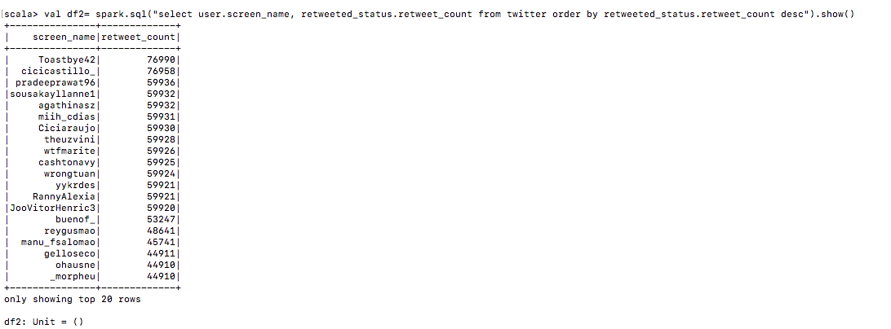

Visualisation: We did the visualization for this using the histogram where the name and count are shown as below.

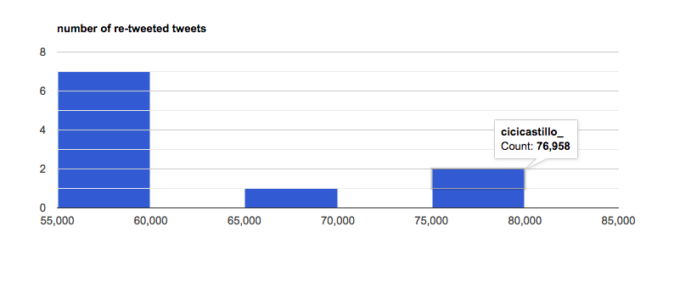

Query 3: This query tells about the person who tweeted the most in the list of tweets.

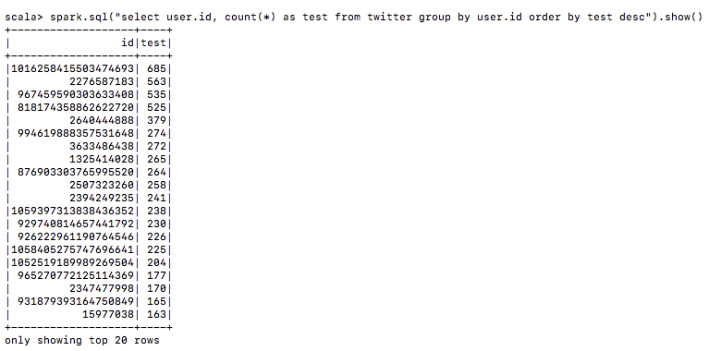

Visualisation: We have done this visualization using pie-chart where each sector describes about the count.

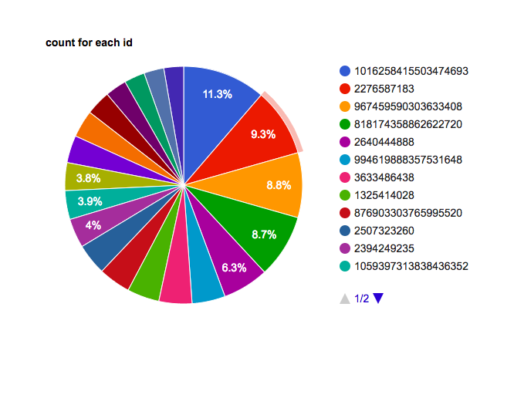

Query4: In this query we have retrieved the count of people who have tweeted about bitcoin, ehereum, monero, ripple, dogecoin and bitcoin gold.

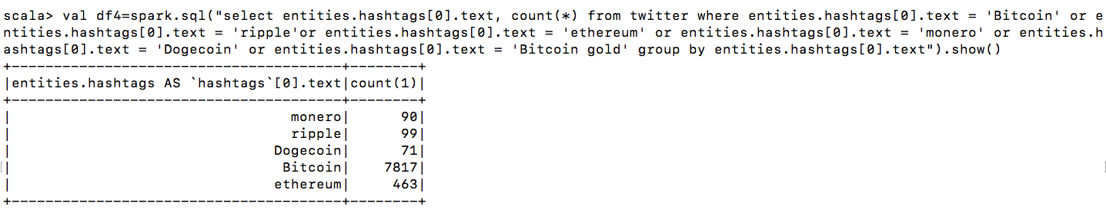

For visualization we are using a column chart that shows the count in x-axis and names in y-axis.

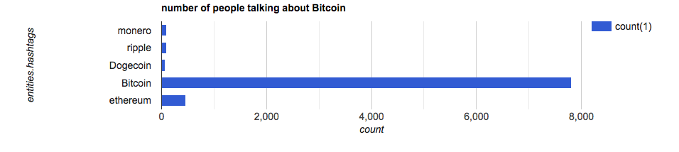

Query 5: In this query we selected the tweets that has different languages through which people have tweeted.

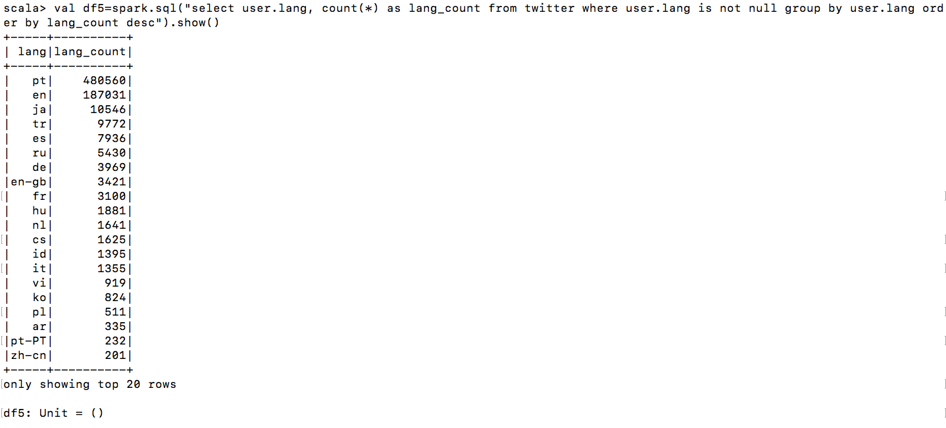

For visualization we have used a donut chart where each and every color specifies about different language.

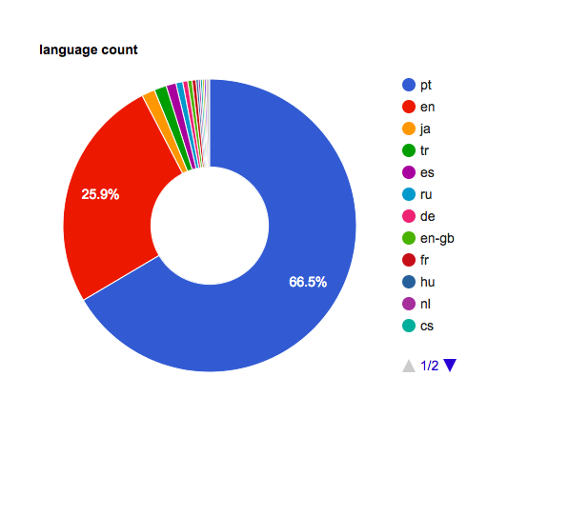

Query6: We have collected the location of the tweets from where the tweets have been originated.

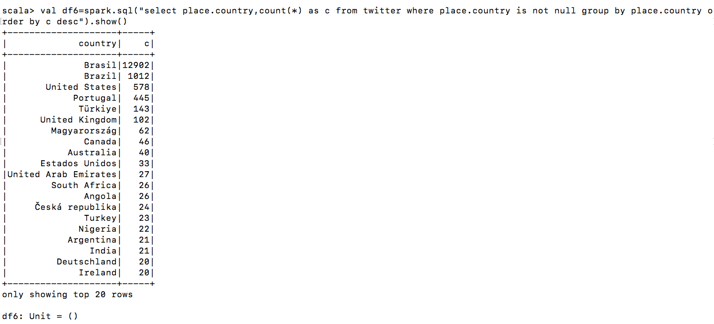

For visualization we have used a geo chart where the highlighted portion shows about the country and the count.

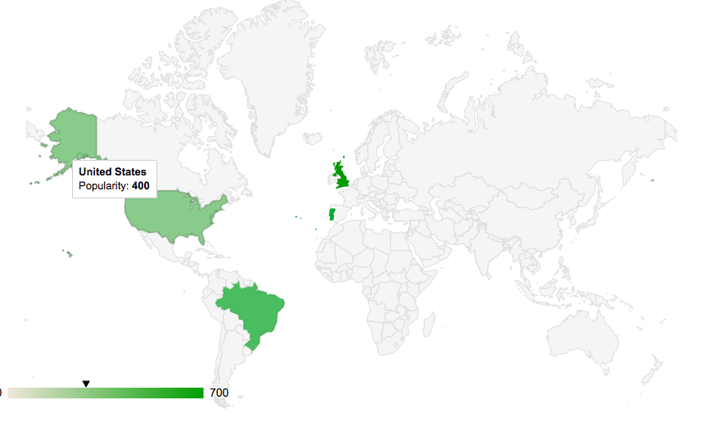

Query7: We have collected the number of sensitive tweets that returns either true or false or null .

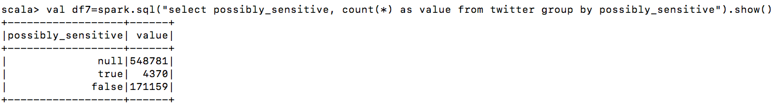

For visualization we have used a 3-D pie-chart that is differentiate between the values.

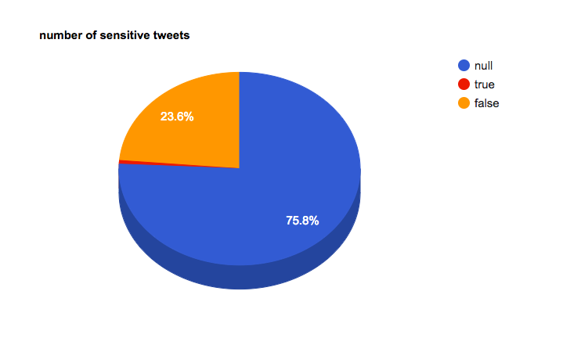

Query8: This query tells about the top most favorited tweets.

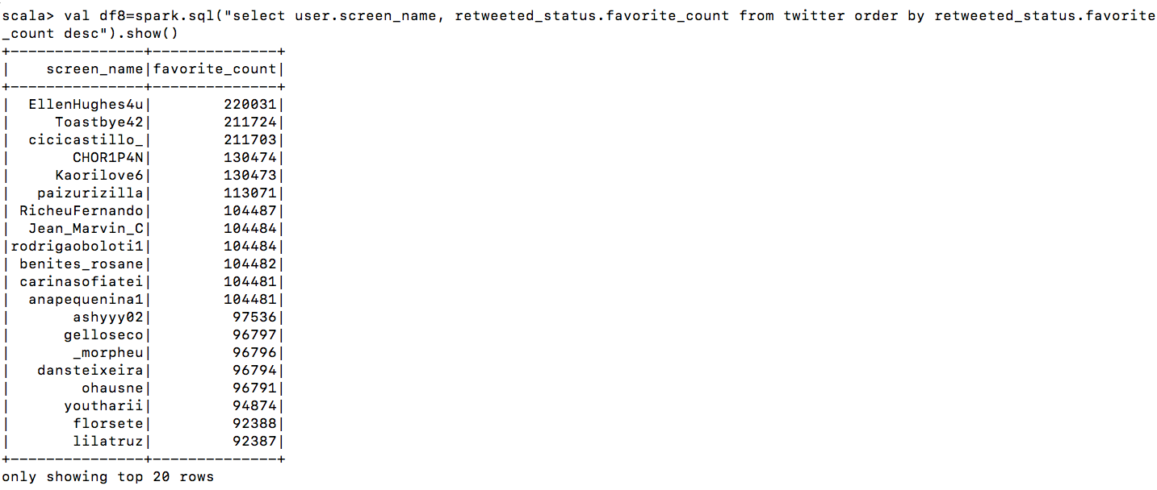

For visualization we have used a bar graph.

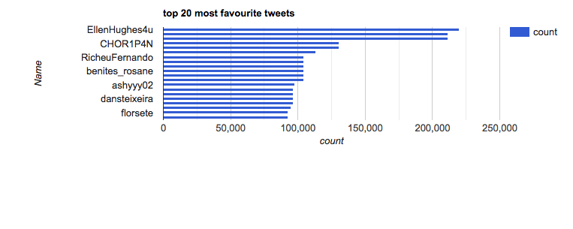

Query9: In this query we collected the top 10 sources from which the people have tweeted.

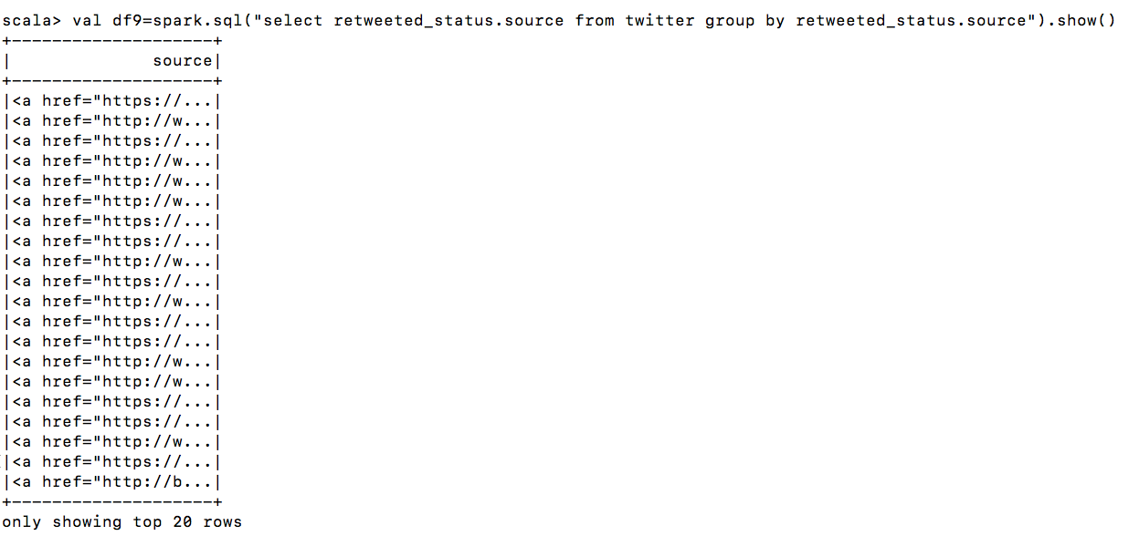

For visualization we have used a table chart that displays the entire output in detail.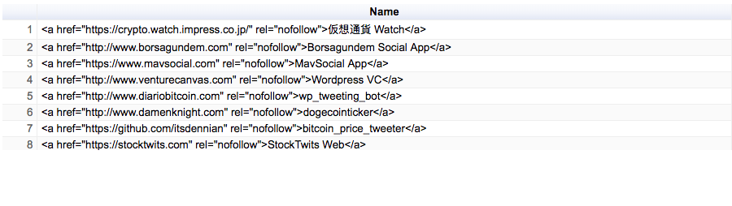

Query10: Query to get the distribution of the tweets at different time intervals.

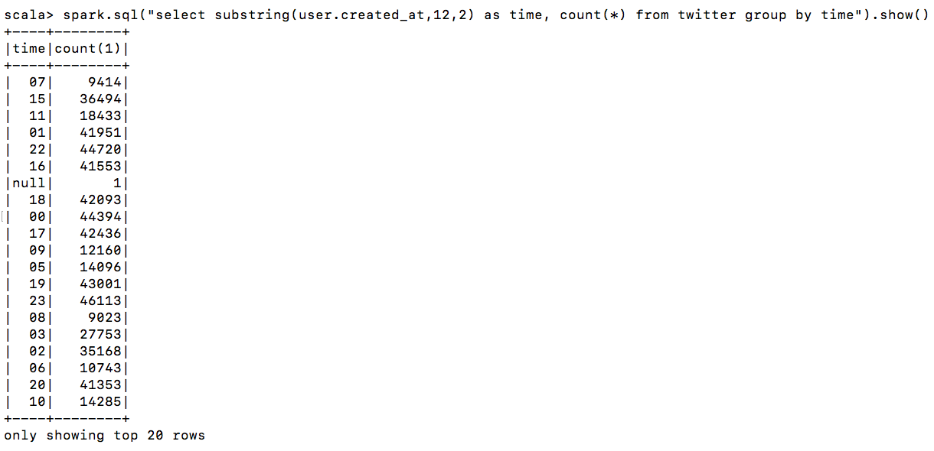

For visualization we have used a histogram to display different time slots.

